## Tubescript :Youtube Video Analyzer

**Project report**

**by**

**Mr. Prithvi Bidkar**

**Department of**

**Artificial Intelligence**

**GHRCE,Nagpur**

## INDEX

|  |  |  |
| --- | --- | --- |
| **Sr. No** | **Topics** | **Page No.** |
| **1** | **Abstract** | **3** |
| **2** | **Introduction** | **4** |
| **3** | **Objectives** | **5** |
| **4** | **Literature survey** | **6** |
| **5** | **Architecture** | **7** |
| **6** | **Proposed Methodology/ System Architecture** | **9** |
| **7** | **Hardware / software specification** | **10** |
| **8** | **Implementation** | **11** |
| **9** | **Conclusion** | **16** |
| **10** | **References** | **13** |

**ARCHITECTURE INDEX**

|  |  |  |
| --- | --- | --- |
| **Sr. No** | **Topics** | **Page. No** |
| **1** | **Proposed methodology/ system architecture** | **8** |
| **2** | **Flow of the project** | **9** |

## ABSTRACT

This project report presents a stream lit based transcription tool designed to facilitate the process of transcription of audio content from YouTube videos The explosive growth in online videos is driving the demand for transcription work of accuracy and efficiency has grown.

Our project meets this need with an easy-to-use platform that uses the YouTube API to extract audio content and create high-quality text. This report describes the system architecture, data flow, and

operational specifications, as well as a demonstration o

The tool not only simplifies the transcription process for content producers, educators and researchers but also serves as a valuable resource to make the video content more accessible and searchable.

It is not just a solution, but a visionary response to the evolving demands of the digital age. Join us on this journey as we explore the creativity, use, and impact of this transformational tool, and together we will unlock the potential of YouTube's vast audiovisual library by making it accessible, on demand, to audiences around the world in, and it makes sense.

The YouTube Transcript Summarizer is a tool designed to save users time by providing them an easy and efficient way to get the gist of any YouTube video they are interested in. The system leverages the power of machine learning to analyse either the transcripts of videos or converts the voice into text and generates accurate abstractive summaries that capture the essence of the content. The system is designed to be user-friendly and accessible.

It also provides a solution that can dominate language overcoming obstacles, simplifying content and improving the overall user experience on it YouTube platform. Huge number of videos are being created and shared on the internet every day. In daily lifestyle, spending time on video is very

solution, it turns problem into frustration which effects our health also. We only need relevant information from the video but sometimes for gaining the attention from the users, they upload misleading thumbnails, description, advertisement, etc. The number of creators is increasing rapidly from year to year, this directly impact the number of videos to be created. The creators in the greed of views might give misleading information rather than giving the correct information. In the videos, creators waste our time by promoting the different brands, repeating the phrase for subscribing the channel, share the video, etc.

## INTRODUCTION

The exponential growth of online video content, led by platforms like YouTube, has changed the way we consume information, entertainment and educational materials. As this digital wave continues to grow, content creators, educators, researchers, and users are encountering a growing need for accessibility and searchability within a multimedia environment. In this context, the task of transcribing audio content from videos becomes not only a convenience, but also a basic requirement for improving the user experience and expanding the reach of video content. It is with this urgent need in mind that this project presents a breakthrough solution: "Youtube Transcript Analyzer Using Streamlit".

YouTube Transcribe Web Tool is a major milestone in audio-to-text conversion for YouTube videos. This project was conceived and developed to respond to the ever-growing demand for accurate, efficient and user-friendly transcription services. This tool integrates seamlessly with the YouTube platform and uses the power of the YouTube Data API to retrieve audio content and convert it to written text. With a user-friendly interface, language support and quality control mechanisms, this innovative tool allows users to effortlessly transcribe YouTube videos, making

-based authoring tool and explore its features, design,

functionality, and utility for different user groups. In the following pages we will highlight the technical complexity of the tool, its driving technologies, and its impact on content and ubiquitous language.

We will also discuss its scalability and potential domain applications diversity, from content creators trying to increase audience engagement to researchers exploring global content .This usage report is not only a testament to technological innovation, but also a bridge to greater integration, user empowerment and democratization of online content.Creating the combination of web technologies, speech recognition and speech support a powerful tool that overcomes language barriers and improves viewer experience. Sometimes it become very difficult for watching video which may have longer duration of time than expected and sometimes efforts

It might be frustrating and time consuming to find for the videos that contains the accurate information regarding our searched topic.This summarizer is helpful for those users who want to accurate information rather than spending their time in watching the video. Summarizer describes the transcipt of the video in the text format so that user can get true information and solution for their problems.Transcripts are an excellent source of information as they contain a textual representation of the audio in a video. Transcript summarization can be achieved through natural language processing (NLP) techniques that extract key phrases and sentences from the transcript.

## OBJECTIVES

Text summarization is a technology that has been rapidly growing with increases in its day-to-day applications. Summarization of text in various scenarios, to be particular of ch towards making the jest of a video being watched clearly understood with having to spend whole duration of the video watching it.

The tool should help users save time by quickly understanding the content of a video without having to watch the entire video. This is especially valuable for viewers who want to determine if a video is worth watching in its entirety.

Summarizing video content can make it more accessible to individuals with hearing impairments or language barriers. The summarizer can provide a text-based alternative for understanding video content.

By generating a transcript summary, the tool can help in indexing and categorizing videos based on their content. This can improve the searchability and discoverability of videos on the platform.

Video creators and marketers can use transcript summaries to optimize their videos for search engines. Summarized text can be used to improve the video's metadata and increase its visibility on search engines like Google.

In educational contexts, a YouTube transcript summarizer can help students and learners quickly grasp the key concepts and information presented in educational videos.

## LITERATURE SURVEY/STUDY OF EXISTING

The use of YouTube transcript summarizers has gained attention from researchers in recent years due to the increasing amount of video content available on the platform. This section presents a literature survey of some of the previous works on YouTube tran

Ponceleon, Edward J. Delph describes the compact representations of video data can enable efficient video browsing. They propose the method which summarizes the long video automatically. Their representations provide the user relevant information about the content with particular sequence examined while preserving the essentials of the content.

proposes an automatic video summarization using Natural Language Processing (NLP) based algorithms. The increasing popularity of YouTube gave us the millions of video repository and hence there is an increase demand for good summarization algorithms to summarize various video without loss of any accurate information of the content. Their proposed system describes the YouTube video transcripts based on which summarized video is generated.

Millions of videos are created and shared on the repository platforms such as YouTube, Reddit, Instagram, etc. It is becoming challenging task to spend time on watching such videos, which may have longer duration. Sometimes efforts of watching the videos may go in vain if we are unable to extract our meaningful information from them but Summarizing transcripts of such videos can help us in extracting the meaningful information from the transcript of video. The YouTube summarization model is helpful in extracting the transcripts and generates the summarized version of it. The model automatically produces a summary containing important sentences and including all relevant information related to the original documentation. Abstractive approach generates a new word from input text making the task more difficult while Extractive approach extract the sentences and phrases from the input.

In 2018, Alapati et al. proposed a method for summarizing YouTube video transcripts using deep learning models. The method used a combination of convolutional and recurrent neural networks to extract relevant information from the transcript. The authors evaluated their method on a dataset of YouTube videos and reported competitive results compared to other summarization methods.

In 2019, Nguyen et al. proposed a method for summarizing YouTube video transcripts using a hybrid approach that combines rule-based and machine learning techniques. The method used a set of rules to extract sentences from the transcript, which were then used to train a machine learning model to generate a summary. The authors evaluated their method on a dataset of TED Talks and reported competitive results compared to other summarization methods.

In 2020, Zen get al. proposed a method for summarizing YouTube video transcripts using a graph-based approach.

## PROPOSED METHODOLOGY/ SYSTEM ARCHITECTURE

**1. User Input:**

- Users provide a valid YouTube video URL through the Stream lit app.

**2. Video ID Extraction:**

- Extract the video ID from the provided URL using regular expressions.

**3. Retrieve Transcript:**

* Utilize the YouTube_Transcript_Api to obtain the video transcript.
* Create a single text string by concatenating the transcript content.

**4. Summarization:**

* Apply the Hugging Face Transformers pipeline for summarization.
* Split the transcript into segments (parts) to manage lengthy videos.
* Generate summarized text for each segment.
* Display the summarized text for the user.

**5. Keyword Extraction:**

* Process the full transcript using the spaCy NLP library to extract keywords.
* Remove stop words and duplicate keywords.
* Present the keywords to the user.

**6. Word Cloud Visualization:**

- Create a word cloud visualization to display the extracted keywords prominently.

**7. Full Transcript Download:**

- Allow users to download the full transcript in a text file format.

**8. Translation:**

- Provide an option for users to translate the transcript to Hindi using the Google Translate API.

**9. Related Videos:**

- Fetch and display related videos based on the title of the input video.

**10. User Profile:**

* Create and manage user profiles, including name and photo.
* Enable users to update their profiles through the Stream lit app.

**11. Save Video to Profile:**

- Allow users to save the current video, along with its summarized text, to their profile.

1. **User Profile Display:** 
   * Display user profiles in the app's sidebar, showing the user's name and photo (if available).
2. **View Saved Videos**:
   * Enable users to view the videos they have saved in their profiles.

The proposed system architecture combines YouTube video processing, natural language processing, summarization, translation, and user profile management to provide a

comprehensive video transcript summarization solution.

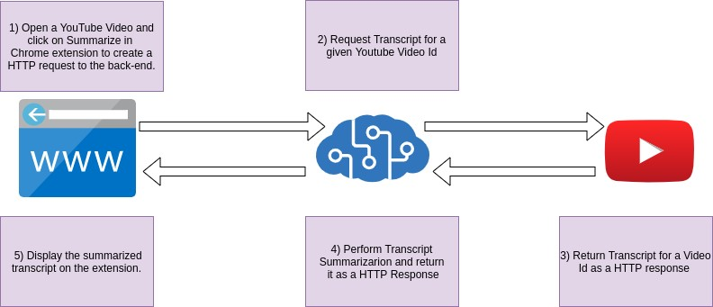

Figure 1: System Architecture of YouTube Transcript Summarizer

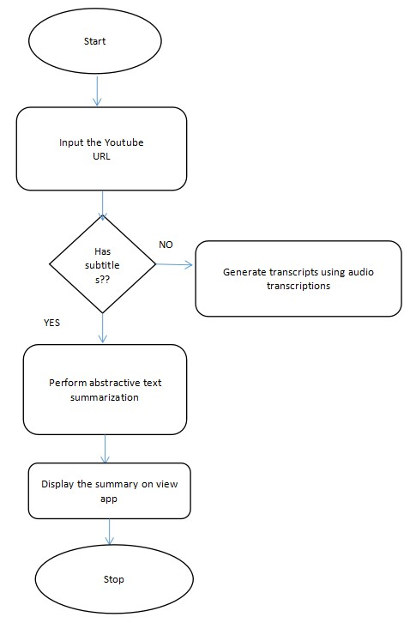

Fig. 2 Flow of Project

## HARDWARE / SOFTWARE SPECIFICATION

1. **Category:** Audio Summarization and Natural Language Processing.
2. **Programming Language:** Python
3. **Tools & Libraries:** Hugging face, Stream lit is a free and open-source framework to rapidly build and share beautiful machine learning and data science web apps. It is a Python-based library specifically designed for machine learning engineers.
4. **IDE:** Visual Studio Code, it is a streamlined code editor with support for development operations like debugging, task running, and version control.
5. **Prerequisites:** Natural Language Processing

## IMPLEMENTATION

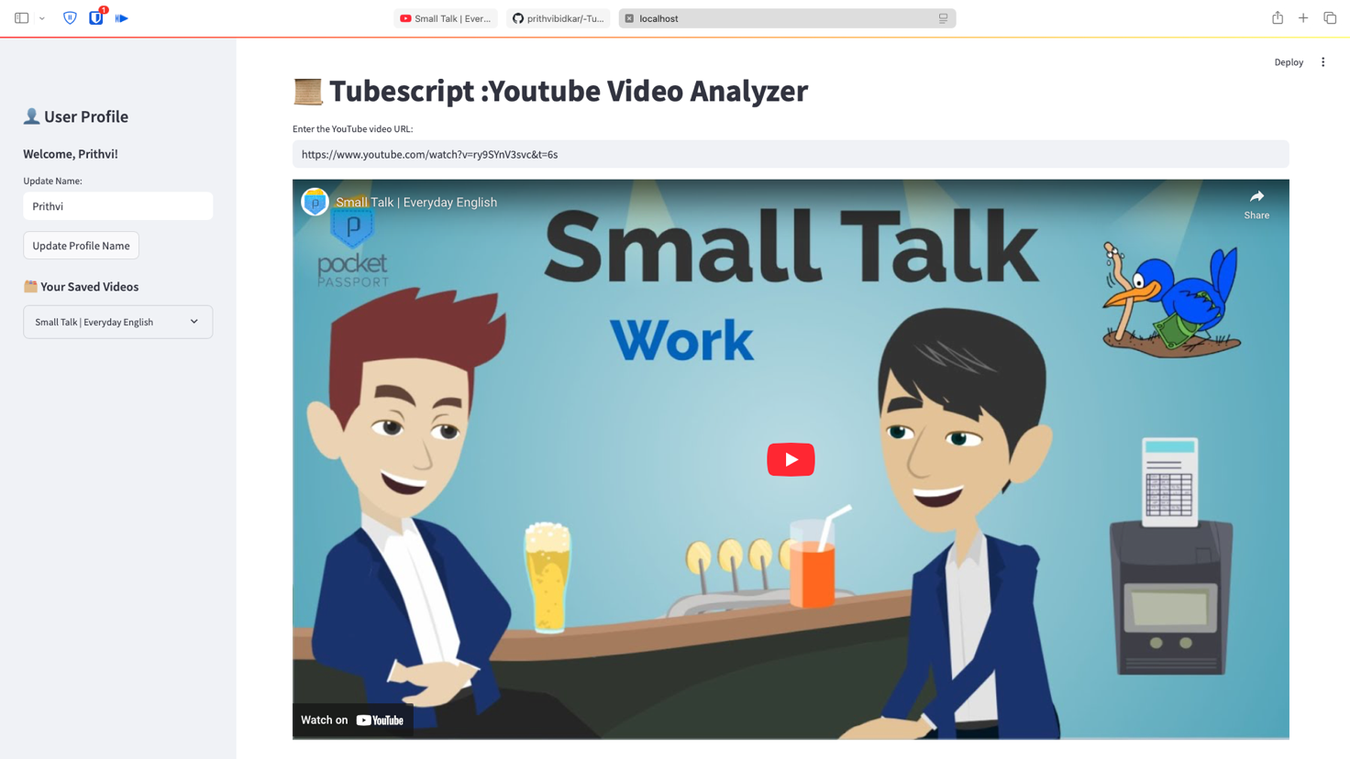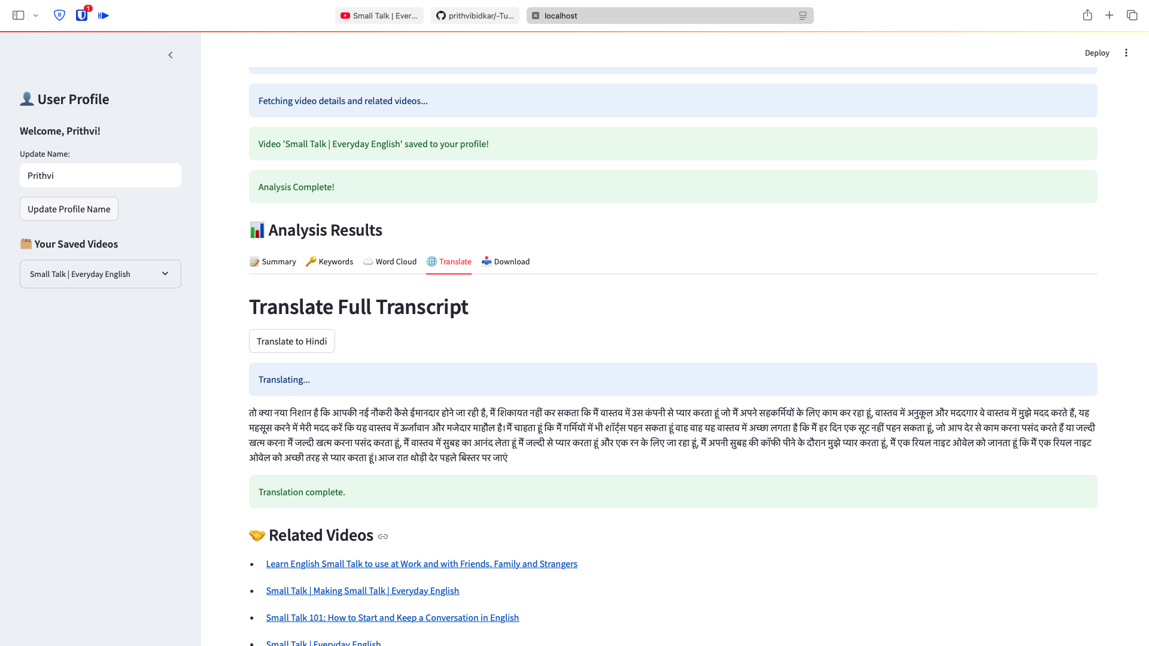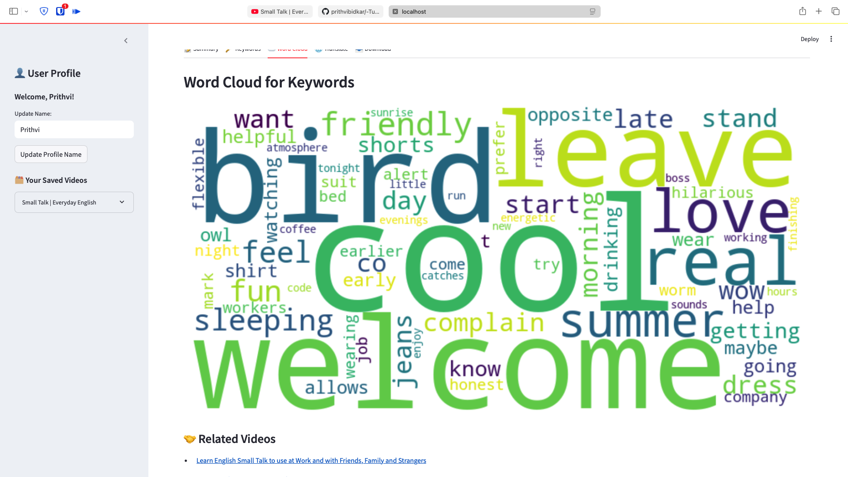

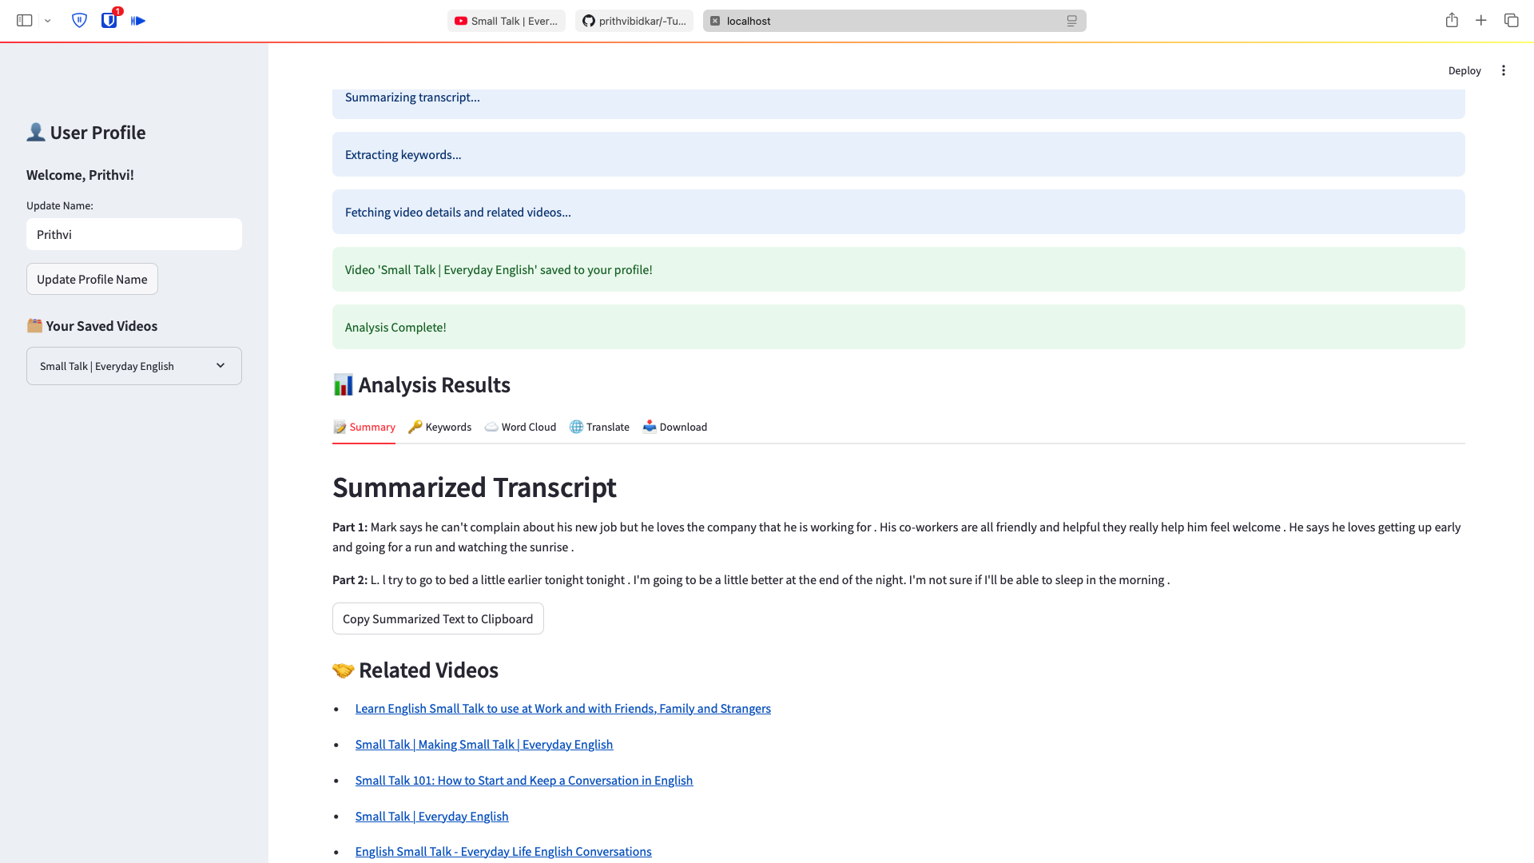

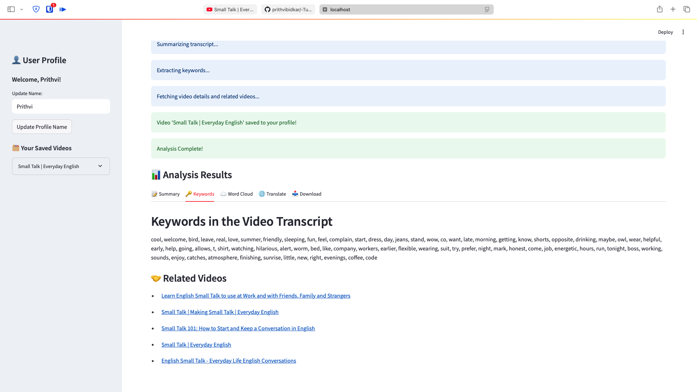

## CONCLUSION

In conclusion, a YouTube transcript summarizer is a valuable tool that serves a variety of purposes for content creators, viewers, and the broader online community. It enhances the accessibility, discoverability, and understanding of video content on the platform. By providing concise summaries of video transcripts, it empowers users to save time, access information more efficiently, and engage with video content in a more inclusive and productive manner.

YouTube transcript summarizers can be a boon for content creators, offering the potential to improve video search engine optimization, receive feedback, and reach a more diverse and global audience through multilingual support. The use of advanced natural language processing techniques ensures that the generated summaries capture the essence of the video content accurately.

## REFERENCES

**[1]** I. Awasthi, K. Gupta, P . S. Bhogal, S. S. Anand and P . K.Soni, ”Natural Language

Processing (NLP) based Text Summariza- tion - A Survey,” 2021 6th International

Conference on Inven- tive Computation Technologies (ICICT), 2021, pp. 1310-1317, doi:

10.1109/ICICT50816.2021.9358703

**[2]** Journal of King Saud University – Computer and Information Sciences: “ Review of

automatic text summarization techniques methods ” By - Adhika Pramita Widyassari,

Supriadi Rustad, Guruh Fajar Shidik. Edi Noersasongko Abdul Syukur, Affandy

Affandy”, De Rosal IgnatiusMoses Setiadi” Faculty of Computer Science, Dian

Nuswantoro Univer- sity, Semarang, Indonesia Department of Electrical Engineering,

STT Ronggolawe Cepu, Blora, Indonesia doi:

**[3]** P . R. Dedhia, H. P . Pachgade, A. P . Malani, N. Raul and M. Naik, ”Study on

Abstractive Text Summarization Techniques,” 2020 International Conference on Emerging

Trends in Informa-tion Technology and Engineering (icETITE), 2020, pp. 1-8, doi:

10.1109/icETITE47903.2020.087.

**[4]** A. Dilawari and M. U. G. Khan, ”ASoVS: Abstractive Summarization of Video

Sequences,”in IEEE Access, vol. 7, pp. 29253-29263, 2019, doi: 10.1109/AC-

CESS.2019.2902507

**[5] 5.** C. M. Taskiran, Z. Pizlo, A. Amir, D. Ponceleon, and E. J. Delp,

“Automated video program summarization using

speech transcripts,

”IEEE Transactions on Multimedia, vol. 8, no. H. Saggion, S. Teufel, D. Radev, a

**[6]** W. Lam, “Meta-evaluation of summaries in a cross-lingual environment using content-based

metrics,” in Proceedings of the 19th international conference on Computational linguistics,

2002, vol. 1.

**[7]** M. Okumura, T. Fukusima, H. Nanba, and T. Hirao, “Text summarization challenge 2 text

summarization evaluation at NTCIR workshop 3,” ACM SIGIR Forum, vol. 38, no. 1, pp.

29–38, Jul. 2004, doi: 10.1145/986278.986284.

**[8]** M. J. Witbrock and V . O. Mittal, “Ultra- summarization: A statistical approach to generating

highly condensed non-extractive summaries,” in Proceedings of the 22nd Annual International

ACM SIGIR Conference on Research and Development in Information Retrieval, SIGIR 1999,

1999, pp. 315–316, doi: 10.1145/312624.312748